Installation Instructions
2022+ Subaru WRX
W9001
Rear trailer light harness
Torklift Central
315 Central Ave N
Kent, WA 98032
253-854-1832
www.torkliftcentral.com
support@torkliftcentral.com
Rev 1: By DH: 02/01/2023

Parts Inventory
Description | Image | Item # | Qty.
Taillight Modulite |  | 56236 | 1
Dual conductor, double insulated wire |  | 1122X- 12/2 | 20’
7” wire ties |  | 12818 | 25
Solderless Butt connectors |  | 11220 | 7
Ring terminals |  | 11751 | 2
Fuse holder |  | 11750 | 1
15 amp fuse |  | 13521 | 1
14” heavy duty wire ties |  | 12069 | 2

This kit uses a splice in modulite that when triggered by a signal from your vehicles electrical system to supply power to the trailer light connector at the appropriate time. The bulk of the load for the trailer lights is supplied by power and ground wires connected directly to the vehicle’s battery.

Step 1: Using a small screwdriver or trim clip removing tool, remove the 3 trim panel clips used to hold the rear hatch striker cover in place (See Figure 1.1).
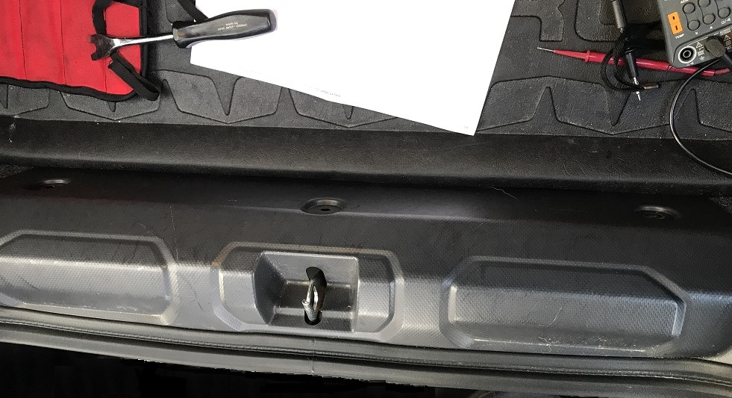
Figure 1.1
Panel push pin retainers
Rear hatch striker panel

Step 2: Remove the rear hatch striker bezel by carefully pulling up and towards the front of the vehicle.

Step 3: Peel back the driver’s and passenger’s side interior trunk panel carpet to get access to the taillight wiring harnesses. Remove the taillight attachment screw covers on both sides by removing the plastic retaining push pin clips and gently prying the screw covers off (See Figure 3.1).

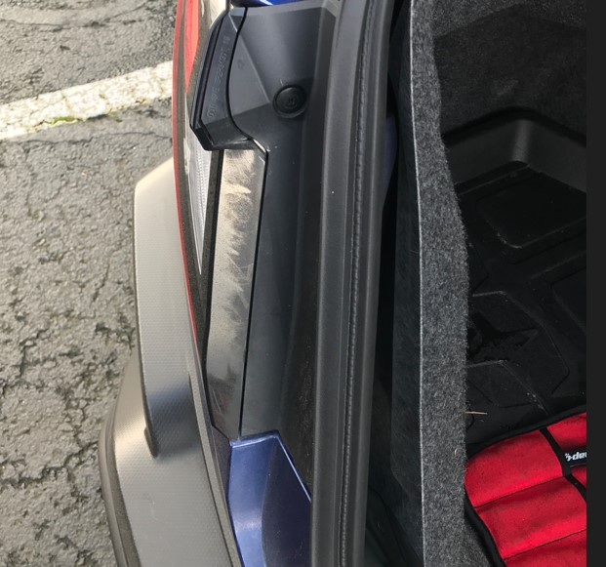
Figure 3.1
Push pin clip
Screw Cover

Step 4: Remove the 2 taillight retaining screws per side on both taillights. Remove taillight assemblies by pulling towards the back of the vehicle. Disconnect the wiring harness connectors on both passenger and driver’s sides. Set the taillight assemblies in the vehicle until the wiring is complete.

Step 5: Run the dual conductor insulated wire from the battery in the engine compartment (Figure 6.1) to the driver’s side rear under the bumper cover. Make sure to route and secure the wires away from anything that gets excessively hot or sharp enough to damage the wires. The most common route is along the driver’s inner fender near the master cylinder down under the vehicle with the brake lines, above the plastic under body panels to the rear of the vehicle on the driver’s side (See Figure 6.2).

Step 6: Attach one of the dual conductor wires (black) to one side of the fuse holder using a solderless butt connector and connect the other side of the fuse holder to the positive terminal of the battery using one of the ring terminals. Leave the 15 amp fuse un-installed until all the wiring is complete. The other wire (white) of the double conductor will connect to the negative battery terminal of the battery or equivalent using the other ring terminal (See Figure 6.1).

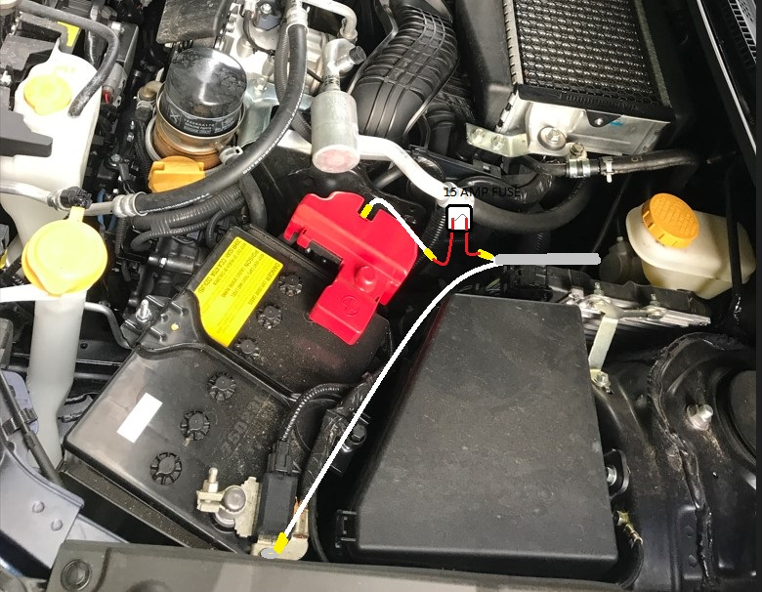
Figure 6.1
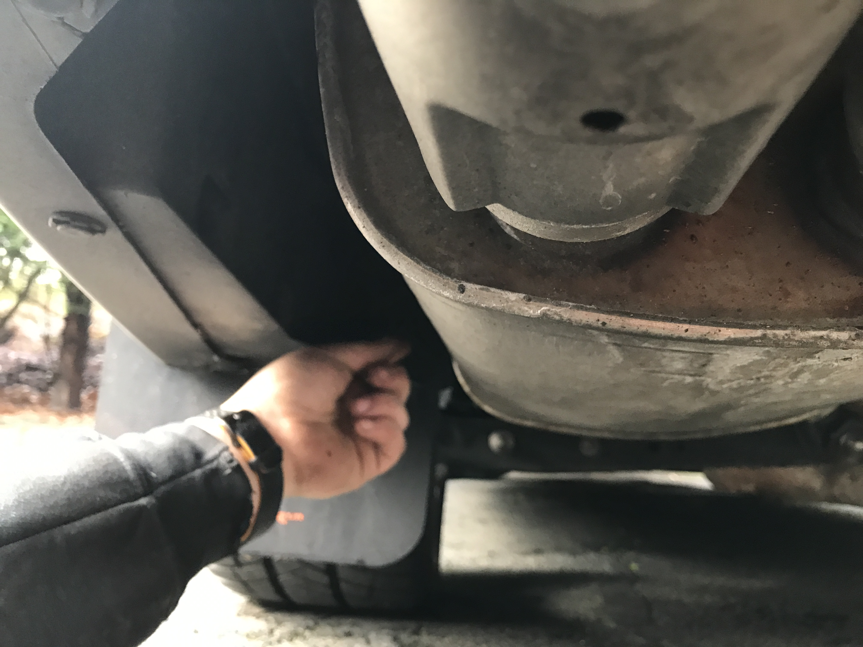
Modulite mounting area
Figure 6.2

Note: After the wiring is done, the modulite will be attached to the hitch cross tube in the driver’s side rear area with 14” wire ties. If an EcoHitch is being installed at the same time as the wiring is being done, it is easier to mount modulite and make the connections while the rear bumper cover is removed.

Step 7: Cut the original ring terminal off the white modulite ground input wire. Cut the dual conductor double insulated wire to length. Use a butt connector to connect the white modulite ground to the white wire of the dual conductor wire. Connect the black dual conductor wire to the black modulite input wire. Run the remaining red, brown, green and yellow input wires up the inside of the bumper cover to behind the drivers side taillight harness area. Run the green modulite input wire across the back of the interior of the car over to behind the passenger side rear taillight. The green wire will be hidden by the rear striker panel when it is reinstalled.

Step 8: Verify you are getting a passenger turn signal power on the Lt green/orange (light side) to green (vehicle side) wire in the vehicle harness going to the passenger side taillight assembly (pin #3). Cut that wire a short distance from the taillight assembly, strip both ends, strip the green modulite input wire, twist one of the stripped ends of the green taillight harness wires together with the green modulite wire, insert both ends into one side of a butt connector and crimp together.

Step 9: Follow the same procedure as used in step #8 for the driver’s side turn signal wire. The factory wire harness wire used will also be Lt green/Orange (light side) and white (vehicle side)(Pin #3) and the modulite input wire for left turn will be yellow.

Step 10: Verify a taillight power signal on the blue (light side), Green/red (Light side)(pin 4) vehicle wire harness, cut the wire a short distance from the taillight assembly, strip insulation from the ends of the blue wire, strip insulation off the end of the brown modulite wire, twist the brown wire conductor and one of the blue harness wire conductors together, insert into a butt connector and crimp the connector. Crimp the other end of the blue wire to the other side of the butt connector.

Step 11: : Verify a stop light power signal is present on the green/yellow (light side) and Brown(vehicle side) (pin 6) vehicle wire harness, cut the wire a short distance from the driver’s side taillight assembly, strip insulation from the ends of the blue wire, strip insulation off the end of the red modulite wire, twist the red wire conductor and one of the blue harness wire conductors together, insert into a butt connector and crimp the connector. Crimp the other end of the brown wire to the other side of the butt connector.
Step 12: Verify all light power signals are correct on the modulite trailer connector. Lightly pull on each wire to verify your crimps are tight.

Step 13: Route the trailer wire harness out and to the approximate center of the hitch receiver behind the bumper cover and attach it to the hitch cross tube.

Step 14: Attach the modulite securely to the hitch cross tube with 14” wire ties. Re-assemble the taillight assemblies and covers removed in previous steps.

Typical OEM wire colors and connector pin locations.
Right turn Lt grn/Or-wht Pin 3 Con R131
Left turn Lt grn/Or-wht Pin 3 Con L131
Stop signal Lt grn/yel-brn Pin 6 Con L131
Tail Signal Grn/red-Blue Pin 4 ConL131

Modulite trailer connector (flat 4)
Green right turn
Yellow Left turn
Brown Taillights
White Ground

Modulite input wire colors
White battery ground -
Black battery +
Red stop signal
Yellow left turn
Green right turn
Brown tail lights

Subaru OEM taillight connector (R131 and L131)

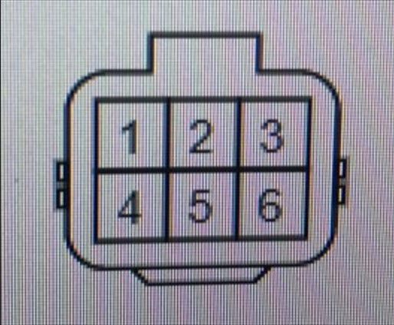

WARRANTY/DISCLAIMER INFORMATION
Torklift Central requires proof of purchase for warranty claim registration, with pictures of any defective product before issuing a replacement. Torklift will not accept claims on any product without proof of purchase, which can be scanned, emailed or mailed to the information provided below. Torklift Central warrants its hitches, custom hitch receivers and accessories (excluding electrical wire harnesses which carry a warranty from their specified manufacturer) from date of purchase against defects in material and workmanship under normal use and service for the ownership life of the original consumer purchaser. Torklift Central will replace free of charge any part that proves defective in material or workmanship when presented to Torklift Central, transportation charges prepaid by purchaser, at the address below.
This warranty is limited to defective parts replacement only. Labor charges and/or damage incurred in installation or replacement, as well as incidental and consequential damages connected therewith are excluded.
This warranty does not include normal wear and tear or the finish and paint. Rusting, cracking or peeling of the finish is also excluded. Some states do not allow the exclusion or limitation of incidental or consequential damages, so the above limitation or exclusion may not apply to you. Any damage to Torklift Central products as a result of misuse, abuse, neglect, accident, improper installation or any use violative of instructions furnished by Torklift Central will void the warranty. This warranty gives you specific legal rights and you may also have rights, which vary from state to state. With warranty service, you may be able to go to a small claims court, a state court or a federal district court.

Although Torklift Central trailer hitches are both tested and rated for towing within the specific capacity label found on each trailer hitch. Torklift Central assumes no liability for vehicle manufacturers warranty due to the use of a Torklift Central trailer hitch being used for towing behind any vehicle or using the trailer hitch in a manner that it was not designed for. Although this specific trailer hitch has a load rating, which includes trailer tongue weight, and a trailer weight carrying capacity, Torklift Central is not responsible for the voiding of any warranty on any vehicle due to factory towing limitations. All vehicle warranties are the sole property and responsibility of the owner of the vehicle that the Torklift Central trailer hitch is installed upon. Torklift Central does not endorse towing behind any vehicle if the vehicles manufacturer states that towing is not recommended. Check your vehicle’s owner’s manual for the proper tow rating of your vehicle.

ADDRESS: 315 Central Ave N. Kent, WA 98032

*WARNING* Your vehicle may have a lower tow rating than this trailer hitch. If your vehicle’s tow rating is less than the rated towing capacity on your Torklift Central trailer hitch, your trailer hitch capacity is limited to your vehicle’s factory rated towing capacity.

*DANGER* Never exceed your vehicle's manufacturer's recommended towing capacity which may be a lower rating than this trailer hitch

